Deploying a Java Spring Boot application on AWS Elastic Beanstalk involves several steps.

Step 1: Prepare the Spring Boot Application
- Build the Application: Ensure your Spring Boot application is packaged as a .jar file. You can do this by running:
mvn clean package
This command will create a JAR file in the target directory (e.g., target/yourapp.jar).
Step 2: Set Up Elastic Beanstalk Environment
- Login to AWS Console: Open the AWS Management Console and navigate to the Elastic Beanstalk service.
- Create a New Application:
  - Click on Create Application.
  - Give your application a name and select Java as the platform.
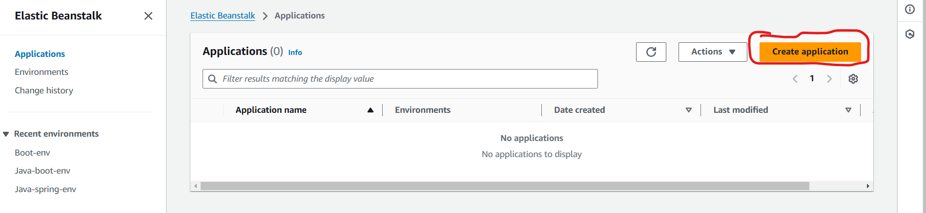
- Configure Environment:
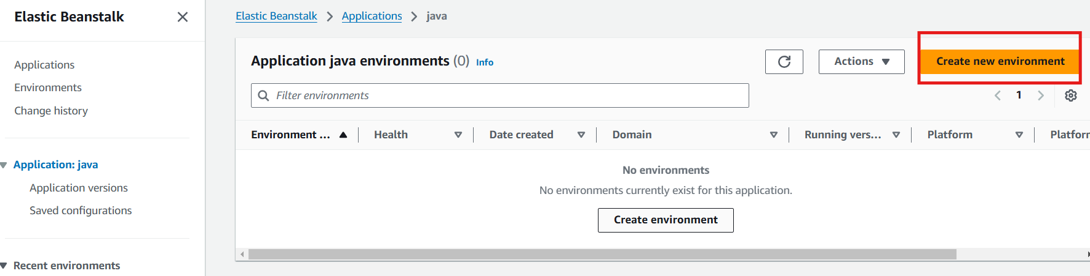

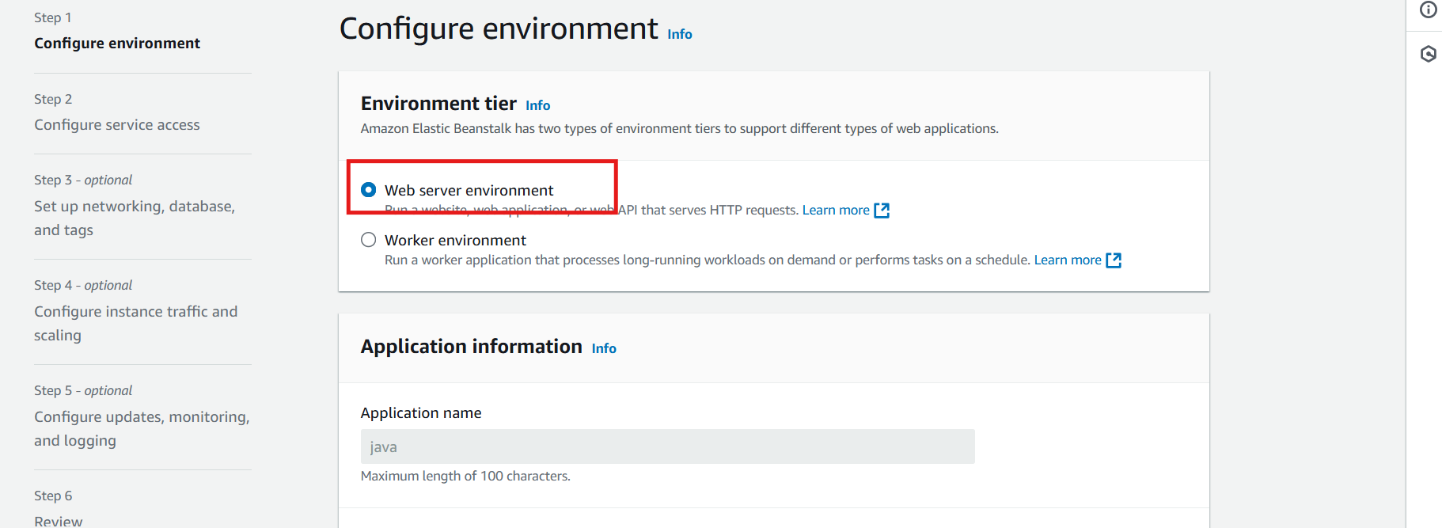
  - In the Platform Branch, select a version compatible with your Java application (e.g., Java 17 running on 64bit Amazon Linux 2).
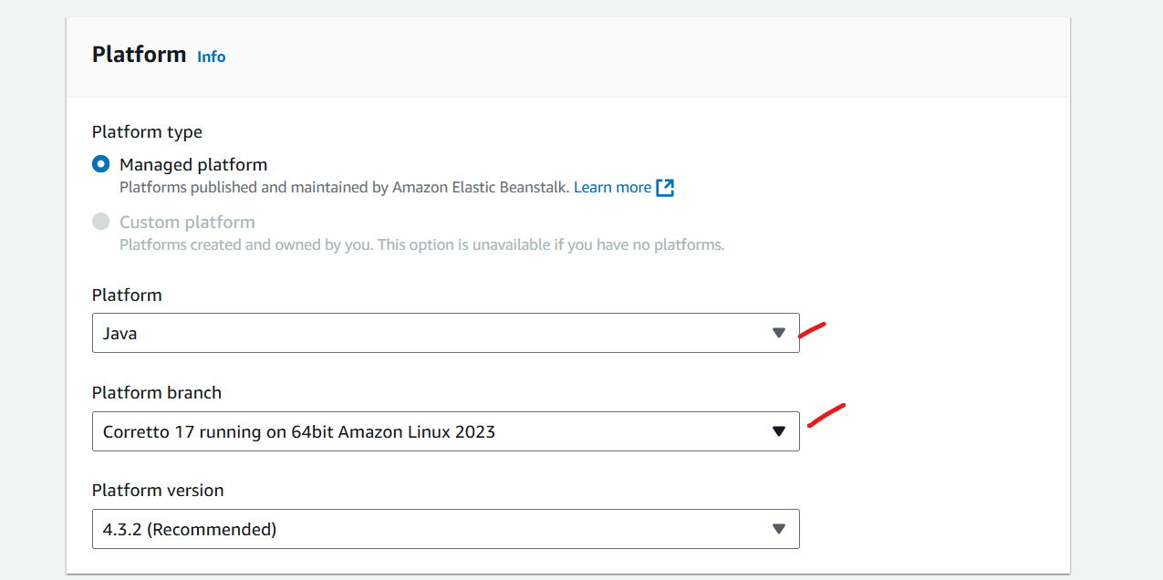
  - Configure additional settings like instance type, environment type (Load balancing or single instance), and key pair if you need SSH access to the instance.
Step 3: Deploy the Application
- Upload and Deploy:
  - In the Application code section, choose Upload your code.
  - Upload the .jar file from the target directory.
  - Click on Deploy.
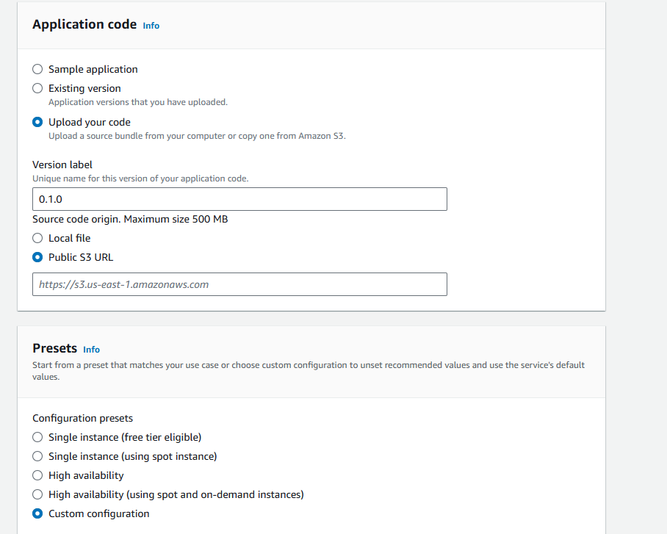

Configure service access

Set Up the Service Role
- In the Elastic Beanstalk Console:
  - Go to Configuration > Security.
- Service Role:
  - Choose Create and use a new service role or Use an existing service role if you already have one set up.
  - If using an existing role, select aws-elasticbeanstalk-service-role from the Existing service roles list. Make sure it has the necessary permissions attached (e.g., AWSElasticBeanstalkService policy).
- View Permissions:
  - You can click on View permission details to see the exact policies attached to this role, which typically includes permissions to manage and monitor Elastic Beanstalk environments and related resources.
Step 2: Select an EC2 Key Pair
- EC2 Key Pair:
  - In the EC2 key pair section, select an existing key pair or create a new one if you don’t have one. This key pair is used to securely SSH into your EC2 instances.
  - To create a new key pair:
    - Go to the EC2 Dashboard.
    - Navigate to Key Pairs > Create Key Pair.
    - Name your key pair and download it to your system.
  - Back in Elastic Beanstalk, select the newly created key pair.
Step 3: Configure the EC2 Instance Profile
- EC2 Instance Profile:
  - Choose beanstalk-instance-profile as the EC2 instance profile. This profile should have managed policies allowing EC2 instances to perform required operations, such as AWSElasticBeanstalkWebTier and AWSElasticBeanstalkWorkerTier.
- View Permissions:
  - Click View permission details to see attached policies and ensure they have the necessary permissions, allowing the instance to interact with AWS services such as S3, CloudWatch, and EC2.
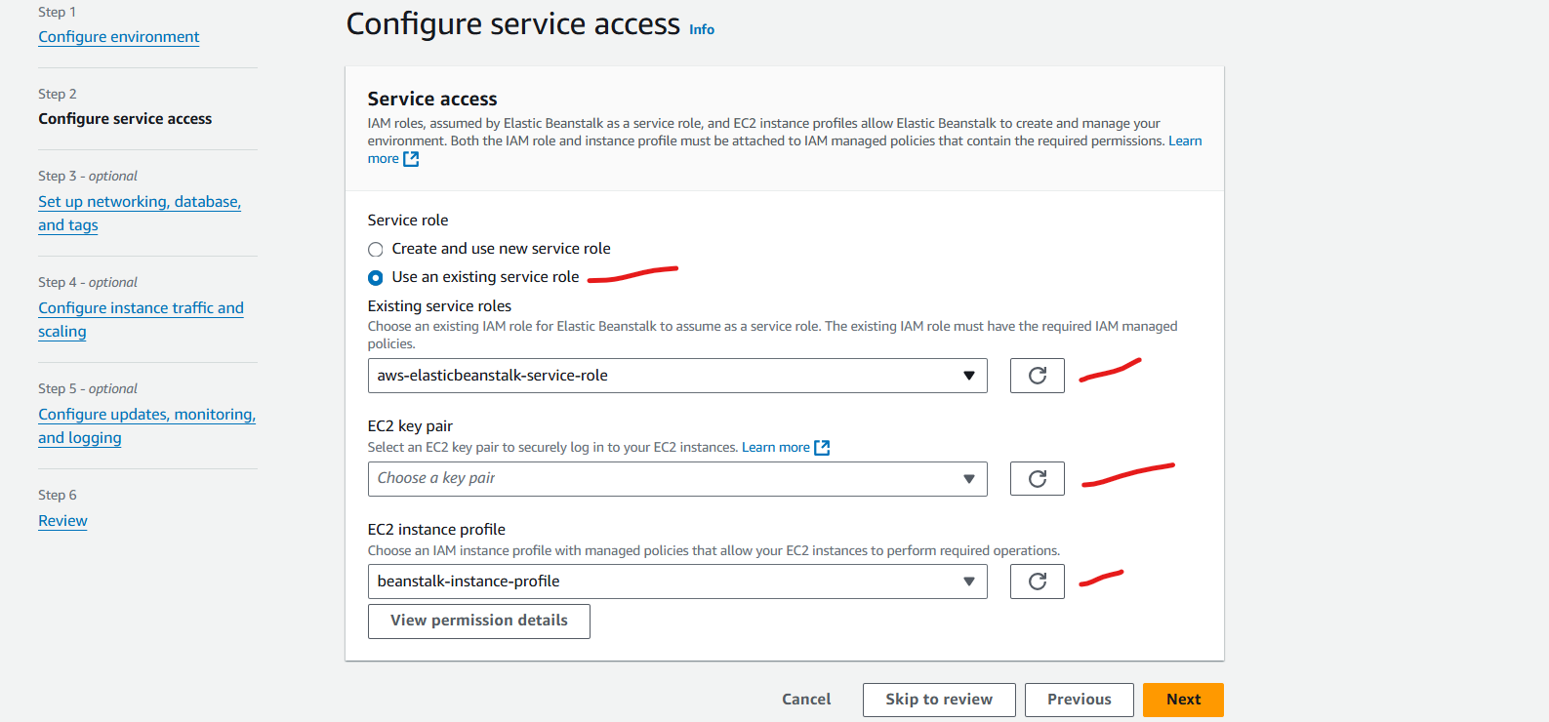
Step 4: Configure Virtual Private Cloud (VPC)
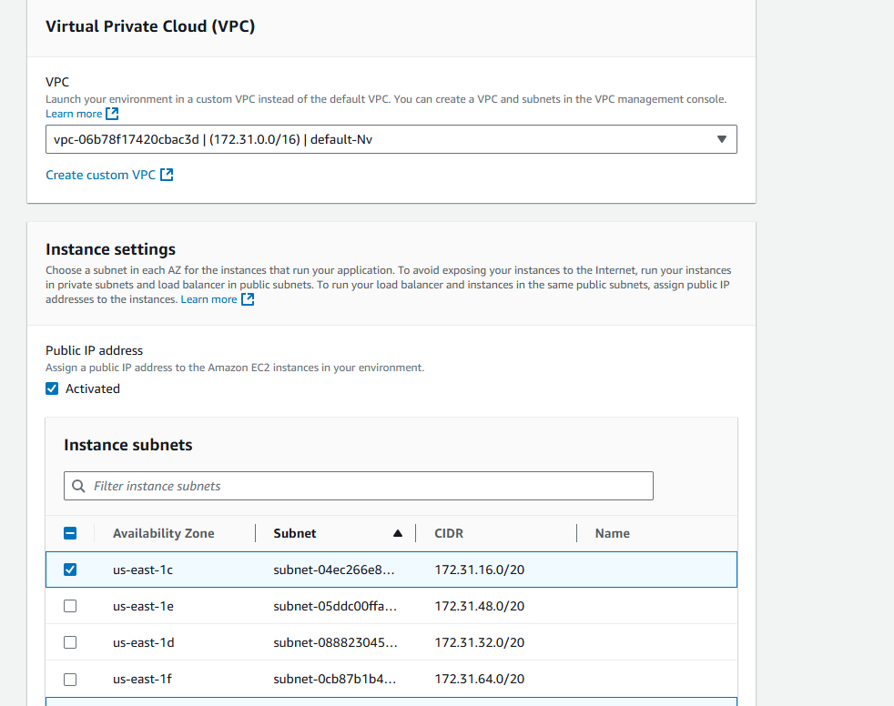

Steps: Configure Instance Settings
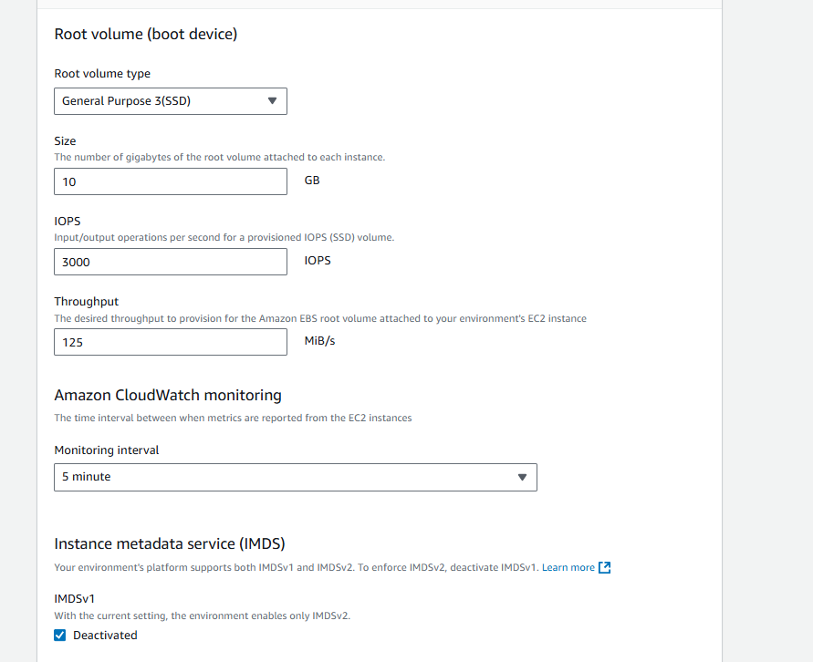

Monitor Deployment: Elastic Beanstalk will start provisioning resources like EC2, Auto Scaling, Load Balancer, and other necessary AWS services. This process may take a few minutes.
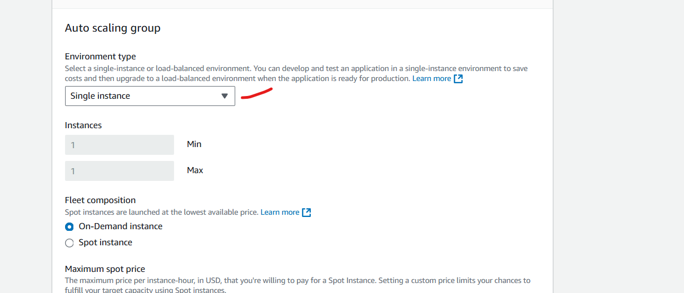

Configure updates, monitoring, and logging
